`````````



Toledo-Lucas County Health Department Newsletter

**September 5, 2014**

National Preparedness Month

***Special Interest Articles:***

• **National Preparedness Month**

• **CDC Director Says U.S. ‘Surging’ Efforts to Stop Ebola Outbreak**

September is National Preparedness Month. The Ready Campaign has established four universal blocks of emergency preparedness; Be Informed, Make a Plan, Build a Kit, and Get Involved. America’s PrepareAthon! builds on this foundation by encouraging millions of Americans to focus on a simple, specific activity that will increase preparedness. America’s Prepar**e**Athon! is a new national community-based campaign for action that focuses on increasing emergency preparedness through hazard-specific drills, group discussions and exercises. National PrepareAthon! days are held every spring and fall. During national Preparedness Month, the Ready Campaign asks that emergency responders, emergency managers, households, communities and places of employment take action by planning a National PrepareAthon! Day on or around September 30th.

This year’s NPM theme is “Be Disaster Aware, Take Action to Prepare.”

**Visit this link to register for National PrepareAthon! Day:**

[www.ready.gov/prepare](http://www.ready.gov/prepare)

Interns in the Community Services division at the Toledo-Lucas County Health Department have been getting involved during National Preparedness Month by creating a blog to help the community stay informed on how to prepare their families for many different types of possible disasters.

**To get further information on disaster preparedness, visit**

[www.readylucas.wordpress.com](http://www.readylucas.wordpress.com)



***Individual Highlights:***

New York legalizes medical marijuana, Berkeley offers it for free

1

Contraceptive microchip: could it revolutionize global birth control?

2

Progress on Children Eating More Fruit, Not Vegetables

2

**New York legalizes medical marijuana, Berkeley offers it for free**



In early July, New York became the 23rd state to legalize medical marijuana. According to Medical News Today, “patients in New York who have serious and terminal illnesses will be allowed access to medical marijuana, to be administered through edibles, oils and vaporizing.” California was the first state to allow marijuana for medical use in 1996. New York mayor Andrew Cuomo hopes this law, the Compassionate Care Act, will bring relief to patients who suffer from extreme pain and illness.

Berkeley, California, is now requiring marijuana dispensaries to provide from medical marijuana to low income patients that require it. In the new law, “low income” is defined as $32,000 or under yearly for a two-person household, and $46,000 or under for a four-person household.

**To read more, visit**

<http://www.medicalnewstoday.com/articles/279457.php>

**CDC Director Says U.S. ‘Surging’ Efforts to Stop Ebola Outbreak**

The world is currently in the midst of the largest Ebola outbreak in history. The Disease is concentrated in West Africa and the countries affected include Nigeria, Sierra Leone, Liberia, and Guinea. The death toll (at the time the article was written) was over 800.

CDC director Tom Frieden plans to send 50 staff members to the affected areas within the next month to help control the deadly disease.

Two Americans, at this time, have contracted the disease from working to treat patients in West Africa. Dr. Kent Brantly was safely and securely transported to Emory University Hospital after being infected in Liberia. His condition is currently improving as he remains in an infectious disease isolation unit. Nancy Writebol, an aid worker, was also transported from Africa to the United States to be treated for Ebola.

**For more information, please visit the following links:**

<http://abcnews.go.com/Health/cdc-director-us-surging-efforts-stop-ebola-outbreak/story?id=24826045>

<http://www.cdc.gov/vhf/ebola/outbreaks/guinea/index.html>

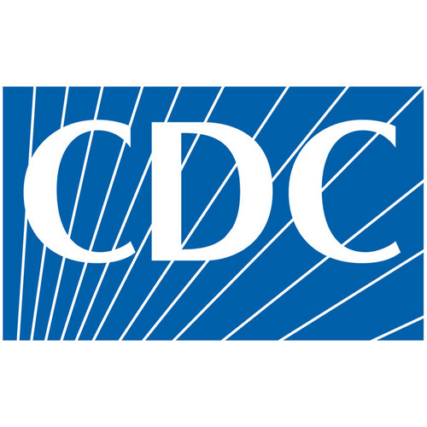

Contraceptive microchip: could it revolutionize global birth control?

What if women could turn on and off their birth control with a remote? This may be a possibility for the general public by the year 2018 with the development of a device from the company MicroCHIPS. The 20 x 20 x 7 mm microchip would be able to be implanted under the skin of women, and would be effective in preventing pregnancy for sixteen years. Contraceptive implants today are only effective for up to five years. The microchip implant works by releasing 30 mcg of levonorgestrel daily, which is a hormone already use in some current birth controls.

Some critics of the device worry that it could be “hacked” by individuals other than the woman it belongs to. The president of MicroCHIPS, Robert Farra, claims that this would not be possible because reprogramming of the unit must take place at a “skin contact level distance.”

**To learn more about this, please visit**

<http://www.medicalnewstoday.com/articles/279323.php>



**Progress on Children Eating More Fruit, Not Vegetables**

According to a report this month from the CDC, American children were eating 67% more whole fruit in 2010 than they were in 2003. This report states that whole fruit has replaced fruit juice as the main contributor to children’s fruit intake as juice consumption for all children decreased by 33 percent. However, over that seven year period, the amount of vegetables eaten by kids did not change significantly. Nine out of ten children lacked adequate vegetable intake from 2003-2010. Fortunately, current movements like “Let’s Move!” have emerged to help children eat even more fruits and vegetables than they did four years ago.

**To read more, log on to**

<http://www.cdc.gov/vitalsigns/fruit-vegetables/index.html?s_cid=cdc_homepage_whatsnew_001>.



We Want Your Input

Holding a training and want others to know about it? Have something you want to share – information from a conference, a presentation you will be conducting, or an interesting article? Send us the details and we will be happy to include it in the next issue of the newsletter. Your feedback is also welcomed.



##### Questions, comments, article suggestions, inquire to:

Don’t Forget to Like Us on Facebook at [www.facebook.com/tlchd](http://www.facebook.com/tlchd)

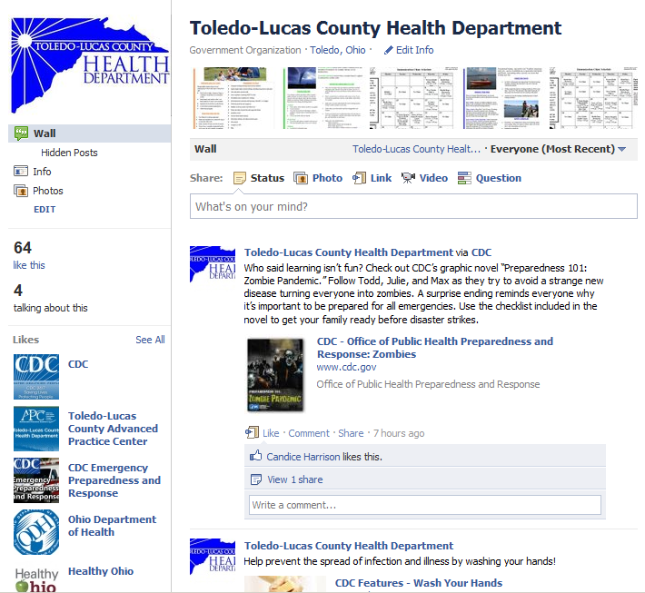

Mahjida Steffin

Clerk 1

635 North Erie Street

Toledo, OH 43604

Phone:

(419) 213-4218

Fax:

(419) 213-4546

E-Mail:

[steffinm@co.lucas.oh.us](mailto:steffinm@co.lucas.oh.us)

You Can Now Follow Us on Twitter! Follow Us at [@ToledoLucasHD](http://twitter.com/#!/ToledoLucasHD)

