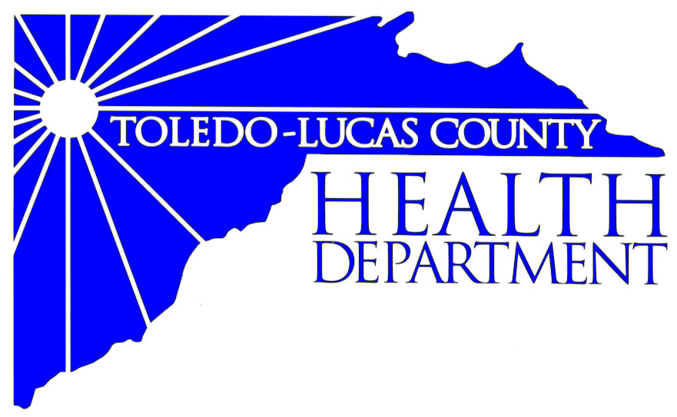

Main Office Western Clinic Site
635 N. Erie St. 330 Oak Terrace Boulevard
Toledo, OH 43604-1317 Holland, Ohio 43528-8993
(419) 213-4100 (419) 213-6255
Fax: (419) 213-4017 Fax: (419) 213-6266

Email: boardofhealth@co.lucas.oh.us
David Grossman, M.D. Larry J. Vasko, R.S., M.P.H
Health Commissioner Deputy Health Commissioner

Lucas County Regional Health District Board Members

Donna A. Woodson, MD, President Mary I. Gregory, RN, MS Ed
Robert R. Reinbolt, MBA, PE Matthew S. Heyrman, MPA
Vice President Donald R. Murray
Darlene L. Chaplin, RN A. Debra Nicotra, RN, PhD
Barbara Conover, MSN, RN Barbara Sarantou
Reynald Debroas Hans Schmalzreid, PhD, RS
Mary E. Duncan Christopher A. Sherman, MD, MBA

Stay Informed. Stay Healthy.

For Immediate Release
November 18, 2013
David Grossman, M.D., Health Commissioner
(419) 213-4018

Health Information: The Friendly Center kicks off Client Choice Food Pantry

The Friendly Center located at 1324 N. Superior Street, Toledo, OH 43604 will be hosting a Client Choice Food Pantry kick-off event on Tuesday, November 19th from 12:00 pm -2:00 pm that will highlight their commitment in offering opportunities for healthier food choices for community residents that are in need.

In partnership with the Toledo-Lucas County Health Department's Creating Healthy Communities Program, grant dollars have helped to convert The Friendly Center’s food pantry into a Client Choice Food Pantry.

A Client Choice Food Pantry provides clients a grocery store like atmosphere, with products arranged on shelves. Clients are provided with a food card as they shop, guiding them to nutritionally balanced selections. This upholds the dignity of the client, while at the same time, meeting their specific health needs.

For more information on the Client Choice kick-off event contact Amelia Gibbon, Executive Director of the Friendly Center at agibbon@friendly-center.org.

For more information on the Client Choice Food Pantry initiative, contact Tony Maziarz, Toledo Lucas County Health Department, Creating Healthy Communities coordinator, maziarza@co.lucas.oh.us

WHAT: Client Choice Food Pantry kick-off
WHEN: Tuesday, November 19, 2013, 12:00 pm – 2:00 pm
WHERE: The Friendly Center
1324 N. Superior Street, Toledo, OH 43604
AVAILABLE: Tony Maziarz, Creating Healthy Communities Coordinator - maziarza@co.lucas.oh.us
The Toledo-Lucas County Health Department’s Creating Healthy Communities grant is funded by the Preventive Health and Health Services Block Grant from the Centers for Disease Control and Prevention (CDC) and administered by the Ohio Department of Health, Bureau of Healthy Ohio, Creating Healthy Communities Program. This publication (journal article, etc.) was supported by Grant Number 04810014CC0413 from CDC. Its contents are solely the responsibility of the authors and do not necessarily represent the official views of CDC.

###

AN EQUAL OPPORTUNITY EMPLOYER
The Toledo-Lucas County Health Department operates in accordance with Title VI of the Civil Rights Act of 1964
Visit us on the web at: www.co.lucas.oh.us/health

