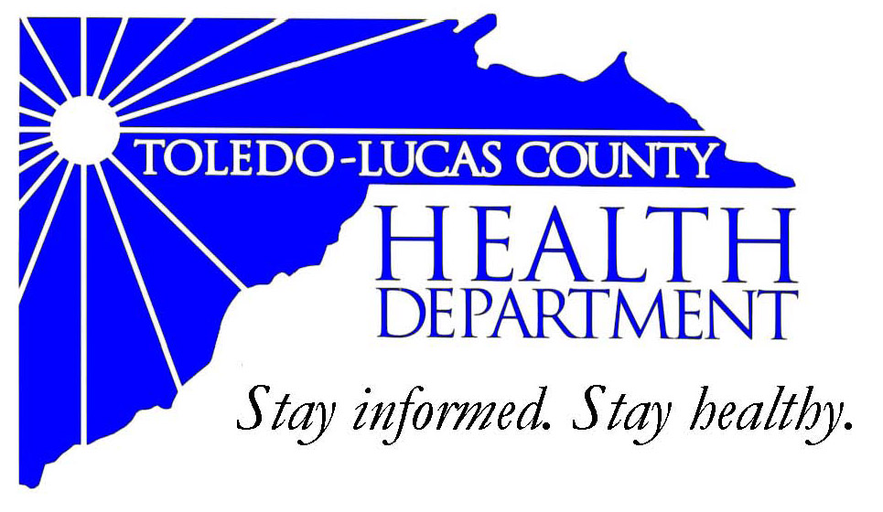
Main Office Western Clinic Site
635 N. Erie St. 330 Oak Terrace Boulevard
Toledo, OH 43604-1317 Holland, Ohio 43528-8993
(419) 213-4100 (419) 213-6255
Fax: (419) 213-4017 Fax: (419) 213-6266

Email: boardofhealth@co.lucas.oh.us
David Grossman, M.D. Larry J. Vasko, R.S., M.P.H
Health Commissioner Deputy Health Commissioner

Lucas County Regional Health District Board Members

Donna A. Woodson, MD, President Perlean Griffin
Robert R. Reinbolt, MBA, PE Matthew S. Heyrman, MPA
Vice President Donald R. Murray
Darlene L. Chaplin, RN A. Debra Nicotra, RN, PhD
Barbara Conover, MSN, RN Barbara Sarantou
Reynald Debroas Hans Schmalzried, PhD, RS
Mary E. Duncan Christopher A. Sherman, MD, MBA

For Immediate Release
November 19, 2013
David Grossman, M.D., Health Commissioner
(419) 213-4018

Health Update: Creating Healthy Communities Grant and Live Well Greater Toledo kick off Stop & Go healthy corner store
The ‘Stop & Go’ convenient store at 1806 Arlington Avenue in south Toledo is the latest Healthy Corner Store. A kick-off event highlighting their commitment to offer healthier food choices to residents in their community will take place Wednesday, November 20th from 2:00-4:00 pm.

Grant dollars from Toledo-Lucas County Health Department and their Healthy Communities Program, in partnership with Live Well Greater Toledo, have helped position the ‘Stop & Go’ into a Healthy Corner Store.

To help recognize the Healthy Corner Store initiative and the healthy food choices offered to residents, WIC dieticians will have food demonstrations and taste testing of WIC approved foods, along with free recipe giveaways. Come join the fun!

A Healthy Corner Store is a corner store or convenient store that promotes the sales of healthy foods through stocking and marketing items such as fresh produce. Low-income communities and neighborhoods with limited access to public and private transportation often rely on corner stores as their main grocer.

For more information on the Healthy Corner Store initiative, contact Tony Maziarz, Toledo Lucas County Health Department, Healthy Communities Coordinator at maziarza@co.lucas.oh.us

WHAT: Healthy Corner Store
WHEN: Wednesday, November 20, 2013, 2:00 pm
WHERE: ‘Stop & Go’ store
1256 Broadway, Toledo, OH 43609
AVAILABLE: Tony Maziarz, Creating Healthy Communities Coordinator - maziarza@co.lucas.oh.us
The Toledo-Lucas County Health Department grant is funded by the Preventive Health and Health Services Block Grant from the Centers for Disease Control and Prevention (CDC) and administered by the Ohio Department of Health, Bureau of Healthy Ohio, Creating Healthy Communities Program. This publication (journal article, etc.) was supported by Grant Number 04810014CC0413 from CDC. Its contents are solely the responsibility of the authors and do not necessarily represent the official views of CDC.
Funding for Live Well Greater Toledo is provided through grants from the Robert Wood Johnson Foundation, YMCA of the USA, YMCA of Greater Toledo and United Way of Greater Toledo.
###

