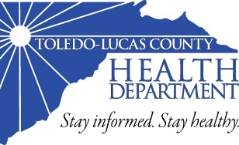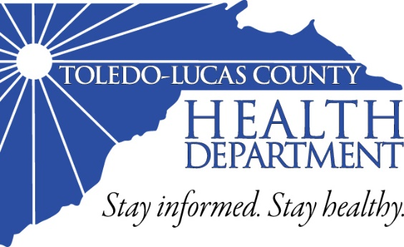

Vital Records

Birth records for all people born in Ohio (all 88 counties) may be conveniently obtained at the Toledo-Lucas County Health Department in about 5-10 minutes. Death certificates for anyone who died in Lucas County can be obtained here as well. We accept all forms of payment options including cash, certified checks, money orders, and credit cards (processing fees apply).

Vital Statistics

(419) 213-4100 (use prompt 6)

Vision Clinic

(419) 213-4209

Shots 4 Tots n Teens

(4190 213-4121

International Travel &   
Adult Immunizations

(419) 213-4163

STD Testing

(419) 213-4209

TB (Tuberculosis) Screening

(419) 213-4209

Pharmacy

(419) 213-4026

Naloxone Training

(419)213-4135

HIV Testing/Pre-exposure  
Prophlaxis (PrEP)

(419) 213-4176

**635 N. Erie St.**

**Toledo, Ohio 43604**

**419.213.4100**

**Hours of operation:**

**8:00 AM – 4:45 PM**

**www.lucascountyhealth.com**

**Please call the above numbers  
to schedule an appointment.**

Health Services

The Toledo-Lucas County Health Department provides high quality preventative services   
to thousands of residents every year.   
The Health Services Division offers testing, treatment, and programs for all ages.



Note–Medicaid in addition to all other insurances are accepted. Uninsured patients will have fees based on a sliding fee scale.

Community Health

The Health Department uses its expertise in the community to help tackle tough public health issues including infectious disease and emergency preparedness. Smart and effective solutions to these challenges are fundamental to keep people in this community healthy, safe, and aware.

Disaster Planning and Training

(419) 213-4152

Epidemiology & Infectious   
Disease Reporting

(419) 213-4161 or (419) 213-4264

Medical Reserve Corps

(419) 213-4152

Environmental Health and Inspections

(419) 213-4100 (use prompt 3)

Environmental Health

Community members of Lucas County expect their food, water, and air to be safe. The Environmental Health Division ensures this through rules and regulations while promoting the long-term health and safety of residents. TLCHD sanitarians provide education through training, inspections and outreach to enhance public health in the community.

Inspections, Licensing and addressing   
issues for:

* Food Facilities
* Wells
* Home Sewage Treatment Systems
* Many other environmental matters

WIC (Women, Infant & Children) Nutrition Program

(419) 213-4422

Cribs for Kids®

(419) 213-4128

Healthy Start

(419) 213-4245

Safe Sleep

(419) 213-4130

Northwest Ohio Syringe Services (NOSS)

(419) 213-2655

60+ Program/  
Matter of Balance Tai Chi

(419) 213-4035

CMH/BCMH (Children with Medical Handicaps)

(419) 213-4126 or

(419) 213-4167

Creating Healthy Communities

(419) 213-4168

Teen Pregnancy

Prevention or   
Youth Development

(419) 213-4828

Office of Minority Health

(419) 213-4095

Tobacco Cessation/

Smoke Free Housing

(419) 213-4558

Community Outreach

The Toledo-Lucas County Health Department’s Outreach programs uphold our commitment to enrich Lucas County by providing services and programs available to all residents in our community. Many services are offered and available to everyone, at any age, even during pregnancy. TLCHD’s Outreach programs are conveniently located throughout the various neighborhoods in addition to the Health Department location.

Stay Informed.

Stay Healthy.

Keeping your food safe to eat and your water safe to drink is our goal. The staff of the Toledo-Lucas County Health Department (TLCHD) works diligently to protect your community. Whether behind the scenes completing an inspection or out in the public promoting health improvement, the TLCHD is here for you! Working hard to improve the health of our community members, we provide a variety of health services, outreach programs, and health promotion efforts throughout Lucas County.