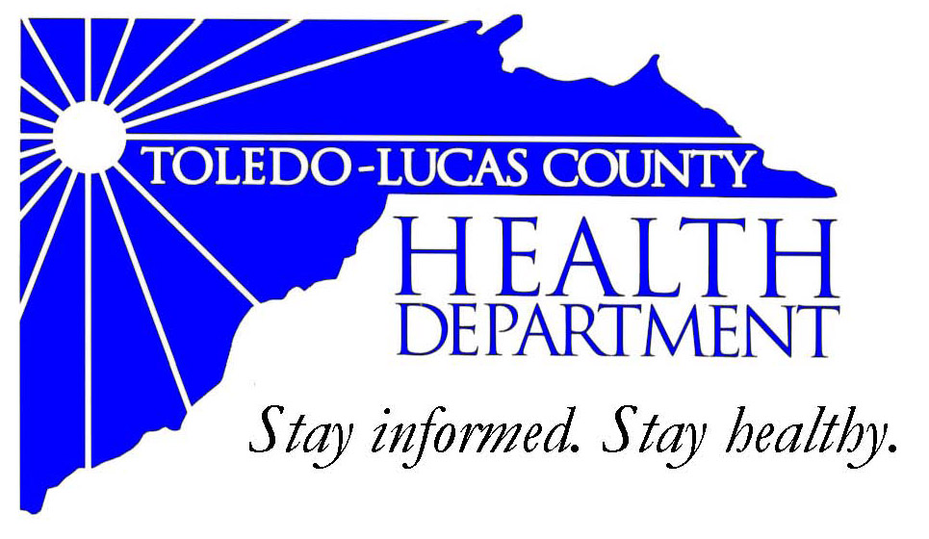
Main Office Western Clinic Site
635 N. Erie St. 330 Oak Terrace Boulevard
Toledo, OH 43604-1317 Holland, Ohio 43528-8993
(419) 213-4100 (419) 213-6255
Fax: (419) 213-4017 Fax: (419) 213-6266

Email: boardofhealth@co.lucas.oh.us
David Grossman, M.D. Larry J. Vasko, R.S., M.P.H
Health Commissioner Deputy Health Commissioner

Lucas County Regional Health District Board Members

Donna A. Woodson, MD, President Perlean Griffin
Robert R. Reinbolt, MBA, PE Matthew S. Heyrman, MPA
Vice President Donald R. Murray
Darlene L. Chaplin, RN A. Debra Nicotra, RN, PhD
Barbara Conover, MSN, RN Barbara Sarantou
Reynald Debroas Hans Schmalzried, PhD, RS
Mary E. Duncan Christopher A. Sherman, MD, MBA

For Immediate Release
November 15, 2013
David Grossman, M.D., Health Commissioner
(419) 213-4018

Health Information: The Annual Great American Smokeout, Thursday, November 21, 2013

The Toledo-Lucas County Health Department is marking the Great American Smokeout on Thursday, November 21, 2013 by encouraging smokers to use the date to make a plan to quit, or to quit smoking that day.

By quitting – even for one day – smokers will be taking an important step towards a healthier life. The health benefits of quitting smoking start immediately from the moment of smoking cessation. Tobacco use remains the single largest preventable cause of disease and premature death in the US, yet about 43.8 million Americans still smoke cigarettes; nearly 1 in every 5 adults.

Individuals can contact the Ohio Tobacco Quit Line at 1-800-784-8669 to speak with an experienced Quit Specialist. The free Quit Line offers support and advice, a personalized Quit Plan, self-help materials and the latest information about medications that can help you quit smoking. Free nicotine patches are available for qualified callers.

If you have any questions or concerns please contact the Health Department at 419.213.4100.

###

AN EQUAL OPPORTUNITY EMPLOYER
Department operates in accordance with Title VI of the Civil Rights Act of 1964
Visit us on the web at: www.lucascountyhealth.com

