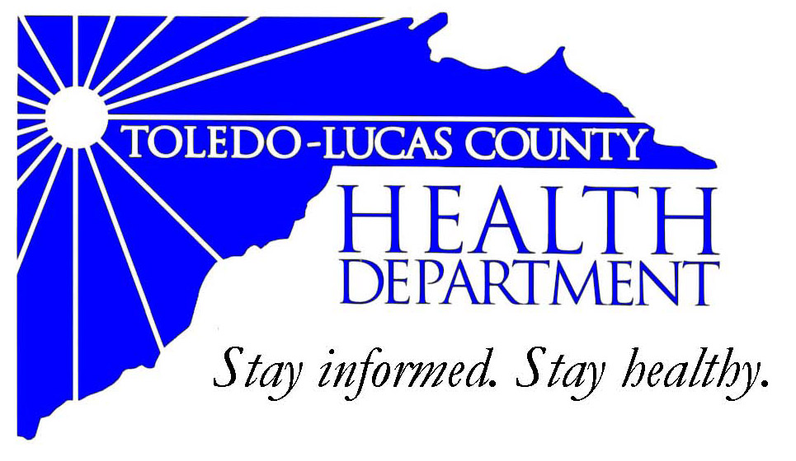
Main Office Western Clinic Site
635 N. Erie St. 330 Oak Terrace Boulevard
Toledo, OH 43604-1317 Holland, Ohio 43528-8993
(419) 213-4100 (419) 213-6255
Fax: (419) 213-4017 Fax: (419) 213-6266

Email: boardofhealth@co.lucas.oh.us
David Grossman, M.D. Larry J. Vasko, R.S., M.P.H
Health Commissioner Deputy Health Commissioner

Lucas County Regional Health District Board Members

Donna A. Woodson, MD, President Perlean Griffin
Robert R. Reinbolt, MBA, PE Matthew S. Heyrman, MPA
Vice President Donald R. Murray
Darlene L. Chaplin, RN A. Debra Nicotra, RN, PhD
Barbara Conover, MSN, RN Barbara Sarantou
Reynald Debroas Hans Schmalzried, PhD, RS
Mary E. Duncan Christopher A. Sherman, MD, MBA

For Immediate Release
May 5, 2014
Public Information Officer
Stacy DeBruyne
(419) 213-4143

Health Update: Press Conference for Stickney Fire – Monday, May 5th 2:45 pm – Health Department DOC

The Toledo-Lucas County Health Department will be holding a press conference in multiple agencies about the fire at Stickney Recycling.

The press conference will be held at 2:45 pm on Monday, May 5th in the Health Department’s Department Operation Center (DOC) on the second floor.

###

AN EQUAL OPPORTUNITY EMPLOYER
AN EQUAL OPPORTUNITY EMPLOYER
The Toledo-Lucas County Health Department operates in accordance with Title VI of the Civil Rights Act of 1964
Visit us on the web at: www.co.lucas.oh.us/health
The Toledo-Lucas County Health Department operates in accordance with Title VI of the Civil Rights Act of 1964
Visit us on the web at: www.lucascountyhealth.com

