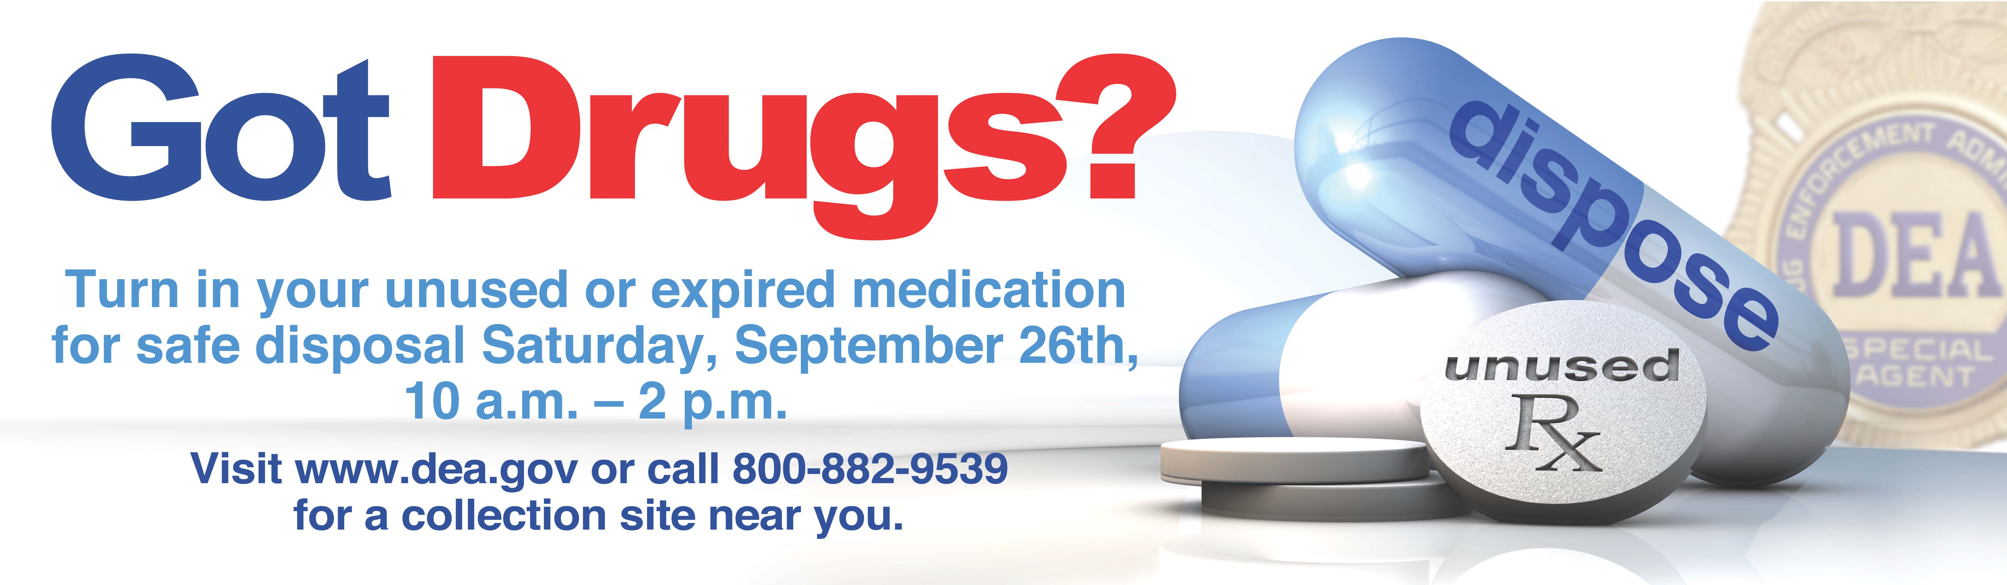

Medication Take Back Day
at the Toledo-Lucas County Health Department
Saturday, April 30TH
10 AM – 2 PM

Items we CAN accept:
- Prescription medications
- Narcotics
- Over-the-counter meds
- Medications samples
- Vitamins
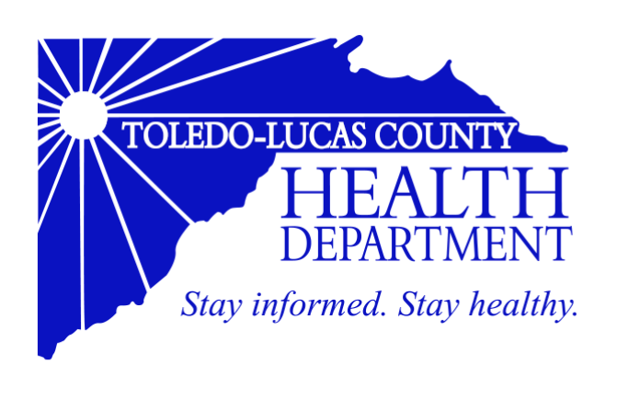

Items we CANNOT accept:
- Needles, syringes, lancets
- IV bags
- Hydrogen peroxide
- Aerosol cans
- Personal care products
- Bloody or infectious waste
- Inhalers or Liquids
- Ointments or lotions
Questions? Call (419) 213-4026

